AUTHOR GUIDANCE
Since the manuscript is reviewed and screened anonymously by advisory editors/ expert editors, the information contained: the title of the manuscript, author's name, institution address, contact number and email for correspondence purposes are written in a separate page.

NOTES:
- This template is a guide to be used to prepare manuscripts for submission. The entire manuscript (text, tables, and graphics) may be submitted in one file. Inserting graphics and tables close to the point at which they are discussed in the text of the manuscript can also be a benefit for the reviewer.
- The manuscripts should be prepared follow the page formatting that attached in the next page.
- Manuscript should be typed in A4 (210 x 297mm) format with 3 cm margins left, right and 2.5 cm margins top and bottom, singled spaced for abstract, references, figure captions and tables, one and a half spaced in Arial 10 for text, using no more than 20 pages for original papers.
- Manuscript file should be saved in the native format of the word-processor used.
- Original resolution of figures, graphics, and tables should be attached in separate pages after original papers.
- There are three page sections in the manuscript file:
- First section page contained the title of the manuscript and the information about author's name, institution address, contact number and email for correspodence purposes.
- Second section pages contained original manuscript including title, Abstract Introduction, Methods, Results and Discussions, Conclusions, Acknowledgements, and References. No information about author's name, institution address, contact number and email for correspodence purposes in the second section pages.
- Third section pages contained original resolution of figures, graphics, and tables and supplementary data (if available).
- To avoid unnecessary errors, author are strongly advised to use the "spell-check" and "grammar-check" functions of word-processor.

JKPK
JURNAL KIMIA DAN PENDIDIKAN KIMIA
p-ISSN 2503-4146 e-ISSN 2503-4154

The Title of Manuscript is typed with Arial font 14, Bold, Space 1, Spacing Paragraph Before 24 pt After 0 pt, then Enter

First Author ^{1,}* and Second author ² (Arial Bold, 11, spasi 1,5)
¹ Institution Name, Faculty, University, City, Country
² Different Institution Name, Faculty, University, City, Country
(Arial, 10, Italic, space1)

* For correspondence purposes, tel/fax : xxxx-xxxxxxx, email: xxxxxxx@xxxxxxxxxxx
Received: | Accepted: Month xx, 201x | Online Published: Month xx, 201x

The Title of Manuscript is typed with Arial font 14, Bold, Space 1 , Spacing Paragraph Before 24 pt After 0 pt, then Enter

Penulis 1^{1*}, Penulis 1², dan Penulis 3² (Arial bold 11, spasi 1, before 9 pt, after 12 pt)
¹Jurusan............., Faculty ................... Universitas ...................................................
Jl. .............................................................................................., Indonesia xxxxx
² Jurusan ............., Faculty ................... Universitas ...........................

........................
Jl. ..................................................., Indonesia xxxxx (Arial italic 10, spasi 1, enter )

* Untuk korespondensi: Tel/Fax (0xxx)xxxxxx, e-mail: ........@.........(Arial 10, spasi 1, after 6 pt)
Received: Month xx, 201x | Accepted: Month xx, 201x | Online Published: Month xx, 201x
ARTICLE INFO | ABSTRACT (Arial Bold 11, Italic, center, spasi 1, before 20 pt, after 10 pt)
Key word: xxxxx xxxxx xxxxx xxxxx (Arial Italic 10, line spacing 1, 3 – 5 words) | An abstract is an important single paragraph in an article. It is usually written maximum in 300 words and embeded by 3-5 key words. An abstract should be covered the research purposes, indicated theory and experiments used, research results and conclusion. Odd and even page are formated different. Odd page format: margin page: top 3,25 cm, left & right 3 cm, bottom 2,5 cm. Paper A4, layout header & footer 1,75 cm. Font page number calibri 12, font “JURNAL KIMIA dan PENDIDIKAN KIMIA (JKPK) ..................................................” calibri italic 9, Align text right. Even page format: margin page: top 3,25 cm, left & right 3 cm, bottom 2,5 cm. Paper A4, layout header & footer 1,75 cm. Font page number calibri 12, font “Nama pengarang, ........................” calibri italic 9, Align text left. (Arial 10, spacei 1).
Article History:
Received: yyyy-mm-dd
Accepted: yyyy-mm-dd
Published: yyyy-mm-dd
*Corresponding Author
Email:
doi:10.20961/jkpk.v..i...ID

© 2023 The Authors. This open-access article is distributed under a (CC-BY-SA License)
Publisher
UPT Mataram University Press

How to cite: f.lastname and F. lastname2, "tittlw," JKPK (Jurnal Kimia dan Pendidikan Kimia), vol. x, no. y, pp. 00-000, yyyy. http://dx.doi.org/10.20961/jkpk.v..i...ID

INTRODUCTION (Arial bold 11space 2)
The manuscript should be written in good and correct Indonesian in accordance with the Enhanced Spelling (EYD) or in English. To avoid unnecessary errors authors are strongly advised to use the "spell-check" and "grammar-check" functions of the word-processor. Regular manuscripts should be prepared with the headings Introduction, Methods, Results and Discussion, Conclusion, Acknowledgement, References, and Supplementary data (if available) in this order.
The References and Citations are written using the IEEE format. Cations with more than one reference can be written with consecutive numbers such as [1-3] or [1,2,5,7]. Make sure that only the citated references are listed in the References. It is recommended when inserting the citations using a management reference such as Mendeley, End Note or otherwise. (Arial 10, space 1.5, column 7 cm).

METHODS (Arial Bold, 11)
Research methods depend on the research design used. Methodological descriptions in experimental research will be different from research studies, action research, case study research or other types of research. Experimental research should be contained the materials and instruments used, and procedures. For chemical education research it describes at least includes participants, research design, data types and data collection techniques, intrument validity, and data analysis. If any chart is made clearly. For procedures that have already been published in other journals, do not need to be written in detail, simply by writing the citation. (Arial, 10, space 1,5)

RESULTS AND DISCUSSION
Results and discussion contains explanations about the results of research that are analyzed and synthezed sharply and critically. The sharpness of analysis and synthesis at least includes descriptions of
Tabel 1. Data hasil penilaian angket dan lembar observasi karakter oleh ahli, pendidik dan teman sejawat

No | Aspec to be valued | Score
 |  | Expert | Educa-tor | Peers
1 | Characteris-tic Material | 18,0 | 16,5 | 15,7
2 | Konstruction | 8,0 | 8,7 | 8,6
3 | Language | 8,0 | 9,0 | 7,6
Total score |  | 34,0 | 34,2 | 31,9

work findings, sharp discussions, and critical comparisons with the work of others. Results and Discussion can be written using sub-chapters if there are several variables used. The positions and styles of sub chapters follow the example below. The space between sub chapters and text is 2 space. (Arial, 10, space 1,5).
1. Tables and Figures (Arial Bold, 10)
Tables and figures sent separately from the text, should be included in the text, not separated. Original resolution of the tables and figure (charts, images) should be attached in separate pages after the References page of the text structure.
a. Tables (space 1,5, before & after 6 pt)
The position of tables entered in the text is adjusted. The size of the letters, the type, and the spacing of the tables may not be the same as the one used in the text. If the table contents of a bit can be made as wide as columns for paper size with 2 columns with the example in table 1. However, if the content is too much can be made as wide as paper for 1 column like the example in table 2.

Table 2. Textural parameters of mesoporous carbon materials after removal silica at different condition

Sample | S_{BET}  (m²/g) | S_{me}  (m²/g) | % me | V_{t}  (cm³/g) | D_{a}  (nm) | D_{b}  nm) | a_{o}  (nm) | t  (nm)
OMCG-1h | 536 | 443 | 83 | 0,52 | 3,5 | 3,5 | TD | TD
OMCG-6h | 756 | 636 | 85 | 0,99 | 5,2 | 4,3 | 10,53 | 5,43
OMCG-24h | 480 | 373 | 78 | 0,97 | 4,5 | 4,1 | 10,06 | 5,36

b. Figures
Picture and charts descriptions are written below the picture and charts by using sequential figures numbering, eg Figure 1., Figure 2., and so on. Figures placement is attempted under the corresponding text, not too far as in the example below.
1) Charts/graphs Example
Below is an example to explain the graph depicted in picture 1. Description is written in singled space and made indented 1 Tab.
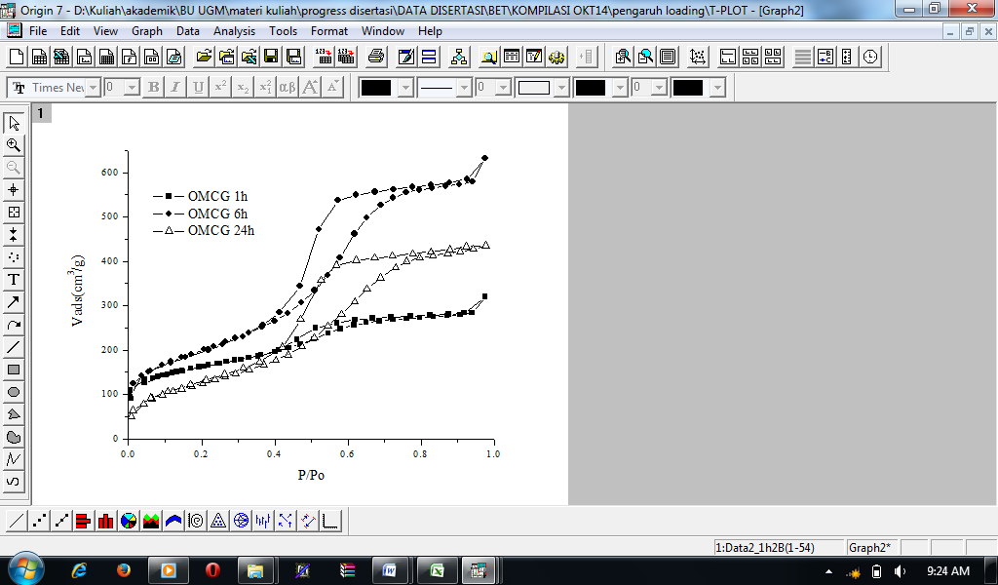
Figure 1. Curve of Nitrogen adsorption–desorption isotherms from the mesoporous carbon material to the relative pressure (P/Po).

2) Figure Example
The example of the following figure is sorted as Figure 2.
Figure 2. TEM Image of carbon mesoporous material after removal of silica using: a. HF 10%; b.HF 20%; c. HF 30% and d. HF 40%.

a) Reaction Example
For long reactions it should be presented as wide as a paper with 1 column as shown in Figure 3.

b) Equation Example
The reaction equation is expressed in a separate line of text with blank spaces above and below, The equation must be clear and the expression used is described in the text. The equations are numbered with Arabic letters in parentheses as in the example below:
(1)

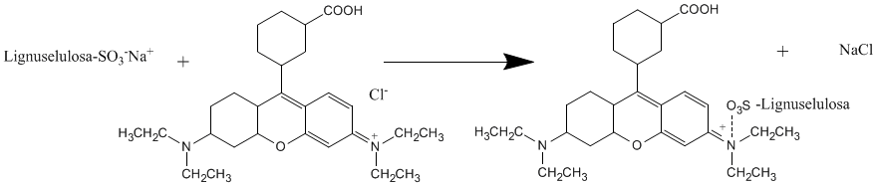
Figure 3. Interaksi model of Lignocellulosic sulphonate with basic violet 10.

CONCLUSION
Conclusions are written clearly and succinctly. Conclusions are not recom-mended to repeat sentences that have been written in the formulation of problems or research objectives. Conclusions should be supplemented by theoretical contributions to previous research, research implications, research weaknesses and future research. (Arial, 10, space 1,5)

Acknowledgement
Generally the last paragraph of the paper is the place to acknowledge people, organizations, and financing (you may state grant numbers and sponsors here). (Arial, 10, space 1,5).

REFERENCES (Arial Bold, 11)
[1] B. K. Hubbard and C. T. Walsh, “Der Aufbau von Vancomycin : so macht es die Natur Angewandte,” Angew. Chemie, vol. 115, no. 7, pp. 752–789, 2003. (An example Article in Journal with 2 authors)

[2] S. Mulyani et al., “The thioesterase Bhp is involved in the formation of β-hydroxytyrosine during balhimycin biosynthesis in amycolatopsis balhimycina,” ChemBioChem, vol. 11, no. 2, pp. 266–271, 2010. (An example Article in Journal with more than 2 authors)

[3] S. Pelzer and W. Wohlleben, “Analysis of the Biosynthesis of Glycopeptide Antibiotics: Basis for Creating new Structures by Combinatorial Biosynthesis,” in Microbial Fundamentals of Biotechnology, V. Braun and F. Götz, Eds. Weiheim: Wiley-VCH Verlag GmbH, 2001, pp. 139–150. (An example Chapter in Book, Book section)

[4] E. A. Birge, Bacterial and Bacteriophage Genetics, 5th ed. New York: Springer Science+Business Media, Inc, 2006. (An example Whole Book)
(Arial, 10, spasi 1).

The title of the journal should be shortened according to the Chemical Abstract Service Source Index (CASSI).

